[GWCTF 2019]pyre
用pycdc反编译得到flag
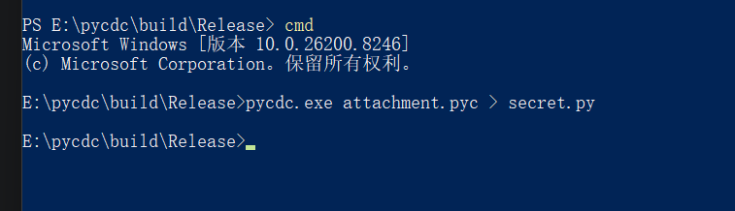
我们输入内容之后，累加再把他们进行异或
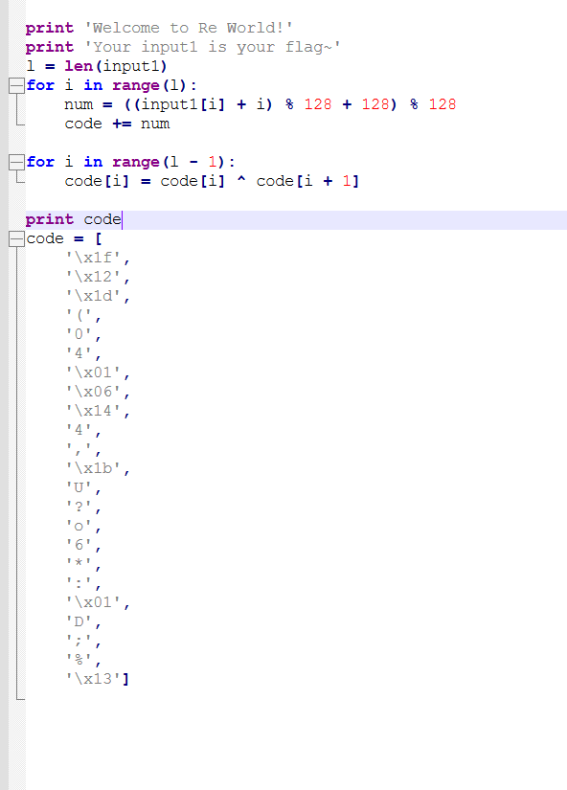
末尾值直接还原，然后从后往前异或
a[l-1] = b[l-1]
for i from l-2 down to 0:
a[i] = b[i] ^ a[i+1]
得到flag

